Credit Scoring with Logistic Regression – 1-Page Summary Report

Problem Statement
A retail bank needs a transparent model that converts an applicant’s Debt-to-Income (DTI) ratio into a probability of default. The logistic regression model representation \( f_{w,b}(x) = \sigma(wx + b) \) supplies that probability. With a small illustrative data set the analyst must implement the sigmoid, form the probability curve, choose a decision threshold, and examine how credit-policy levers (w, b, threshold) affect the share of applicants that would be declined.

Solution Strategy
- Define binary training data (DTI feature, default label 0/1) and visualise the outcomes.
- Implement the sigmoid σ(z) = 1/(1+e^(−z)) and verify its limiting behaviour.
- Build the logistic model f_w,b(x) = σ(wx + b) and plot the resulting probability curve together with the decision boundary.
- Convert probabilities into hard decisions via a configurable threshold (risk appetite).
- Provide vectorized and optional scipy alternatives; add residual/accuracy checks.
- Run a simulation that lets the user change w, b and the threshold and immediately see the impact on approval rate.

Solution
With parameters w = 2.0, b = −4.0 the model yields a decision boundary at DTI ≈ 2.0. At threshold 0.5 the six training applicants are classified perfectly (accuracy 100 %). New applicants with DTI = 0.8 / 1.8 / 2.7 receive probabilities 0.08 / 0.40 / 0.80 and are labelled LOW / LOW / HIGH risk respectively. Raising the threshold from 0.3 to 0.7 reduces the number of high-risk flags from 3 to 2 out of 6, illustrating the classic risk–volume trade-off.
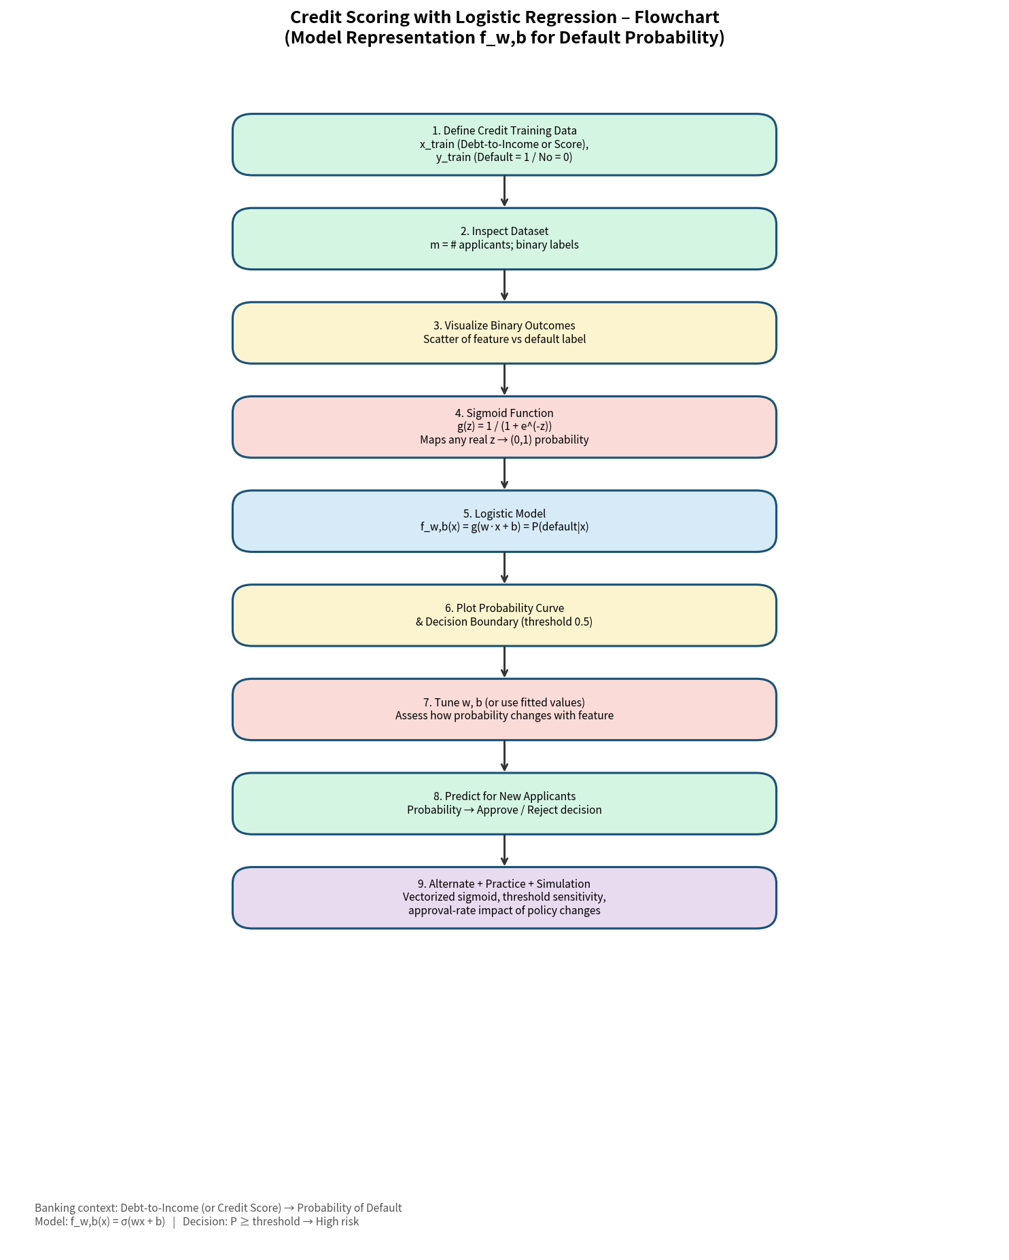
Figure 1 – Workflow flowchart
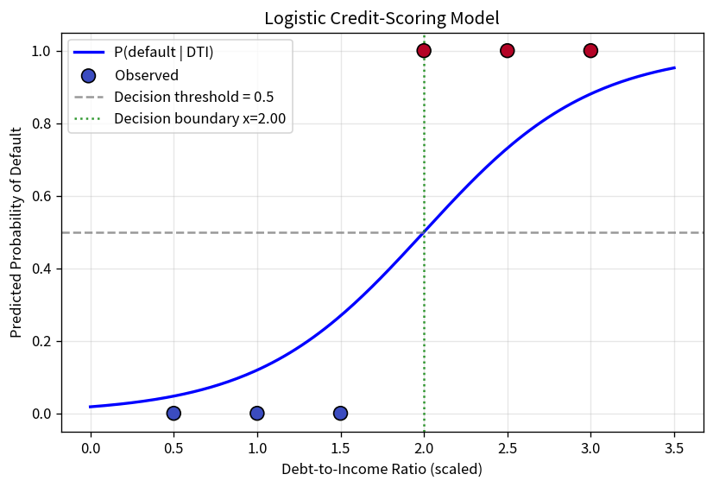
Figure 2 – Probability curve and decision boundary
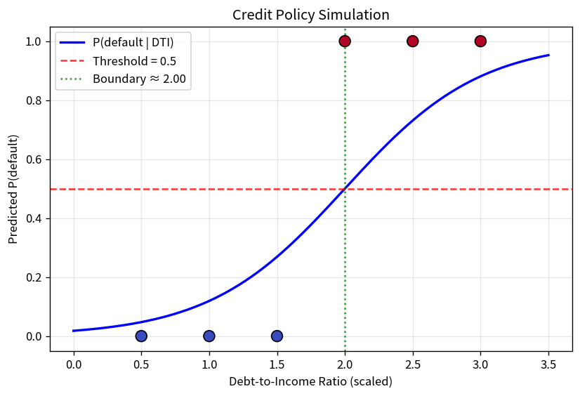
Figure 3 – Credit-policy simulation (threshold & boundary)

Key Takeaways
- Logistic regression maps a linear credit score into a well-calibrated probability of default via the sigmoid.
- The decision threshold is the primary policy lever that translates model output into approve/reject (or high-risk pricing) actions.
- Changing w or b moves the entire probability curve and therefore the location of the decision boundary on the DTI axis.
- A simple simulation of threshold and parameter changes quickly communicates the volume-versus-risk trade-off to Credit Committees.
- This notebook is pedagogical; production PD models are estimated on large historical portfolios under strict regulatory governance.

